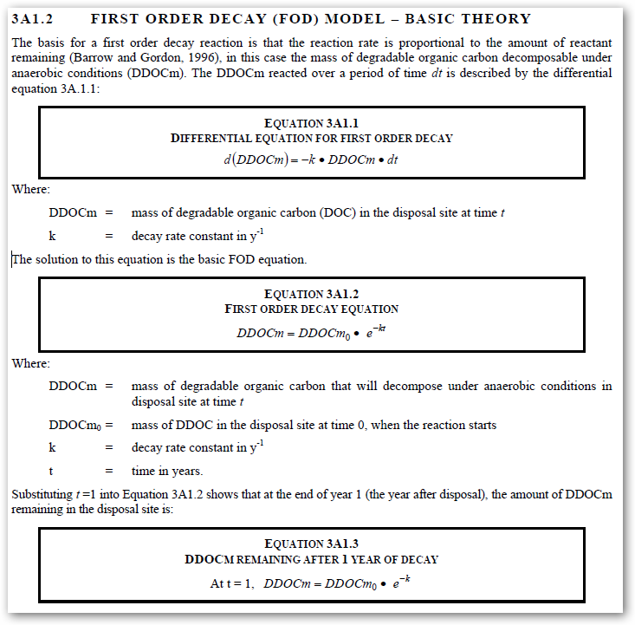

Sample Data

Note – at the end of year 1 the initial 100 will have decomposed to 90.5

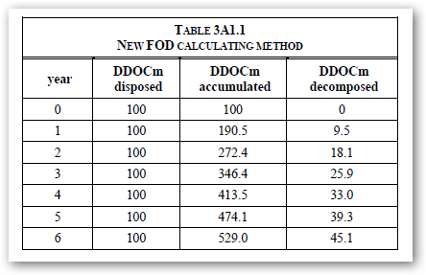

Equation 2A1.2 Expressed in Corticon

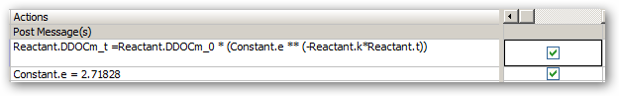

Result from Corticon = 90.48

